

Compensation and Pension Record Interchange (CAPRI)

Kidney Conditions (Nephrology)

Disability Benefits Questionnaire (DBQ)

Workflow

April 2011

Department of Veterans Affairs
Office of Enterprise Development
Management & Financial Systems

Revision History

Date | Description (Patch # if applicable) | Author | Technical Writer
1/21/2011 | Document created | M. Guthrie | N/A
4/1/2011 | Revisions and corrections for patch 163 | M. Guthrie | N/A

Table of Contents

1 Introduction 1
1.1 Purpose 1
1.2 Overview 1
2 Kidney Conditions (Nephrology) DBQ 2
2.1 Name of patient/Veteran 2
2.2 Section 1. Diagnosis 3
2.3 Section 2. Medical History 11
2.4 Section 3. Renal dysfunction 12
2.5 Section 4. Urolithiasis 18
2.6 Section 5. Urinary tract/kidney infection 22
2.7 Section 6. Kidney transplant or removal 25
2.8 Section 7. Tumors and Neoplasms 27
2.9 Section 8. Other pertinent physical findings, complications, signs and/or symptoms 32
2.10 Section 9. Diagnostic testing 34
2.11 Section 10. Functional impact 43
2.12 Section 11. Remarks, if any 44
3 Kidney Conditions (Nephrology) DBQ-AMIE Worksheet 45

Table of Figures and Tables

Figure 1: Template Example: DBQ - Standard VA Note 1
Figure 2: Print Example: DBQ – Standard VA Note 1
Figure 3: Template Example: DBQ – Kidney Conditions (Nephrology) – Name of patient/Veteran 2
Figure 4: Print Example: DBQ – Kidney Conditions (Nephrology) – Name of patient/Veteran 2
Figure 5: Template Example: DBQ – Kidney Conditions (Nephrology) – 1. Diagnosis 10
Figure 6: Print Example: DBQ – Kidney Conditions (Nephrology) – 1. Diagnosis 11
Figure 7: Template Example: DBQ – Kidney Conditions (Nephrology) – 2. Medical History 12
Figure 8: Print Example: DBQ – Kidney Conditions (Nephrology) – 2. Medical History 12
Figure 9: Template Example: DBQ – Kidney Conditions (Nephrology) – 3. Renal dysfunction 17
Figure 10: Print Example: DBQ – Kidney Conditions (Nephrology) – 3. Renal dysfunction 17
Figure 11: Template Example: DBQ – Kidney Conditions (Nephrology) – 4. Urolithiasis 21
Figure 12: Print Example: DBQ – Kidney Conditions (Nephrology) – 4. Urolithiasis 21
Figure 13: Template Example: DBQ – Kidney Conditions (Nephrology) – 5. Urinary tract/kidney infection 24
Figure 14: Print Example: DBQ – Kidney Conditions (Nephrology) – 5. Urinary tract/kidney infection 25
Figure 15: Template Example: DBQ – Kidney Conditions (Nephrology) – 6. Kidney transplant or removal 27
Figure 16: Print Example: DBQ – Kidney Conditions (Nephrology) – 6. Kidney transplant or removal 27
Figure 17: Template Example: DBQ – Kidney Conditions (Nephrology) – 7. Tumors and Neoplasms 31
Figure 18: Print Example: DBQ – Kidney Conditions (Nephrology) – 7. Tumors and Neoplasms 31
Figure 19: Template Example: DBQ – Kidney Conditions (Nephrology) – 8. Other pertinent physical findings, complications, signs and/or symptoms 34
Figure 20: Print Example: DBQ – Kidney Conditions (Nephrology) – 8. Other pertinent physical findings, complications, signs and/or symptoms 34
Figure 21: Template Example: DBQ – Kidney Conditions (Nephrology) – 9. Diagnostic testing 42
Figure 22: Print Example: DBQ – Kidney Conditions (Nephrology) – 9. Diagnostic testing 42
Figure 23: Template Example: DBQ – Kidney Conditions (Nephrology) – 10. Functional impact 43
Figure 24: Print Example: DBQ – Kidney Conditions (Nephrology) – 10. Functional impact 43
Figure 25: Template Example: DBQ – Kidney Conditions (Nephrology) – 11. Remarks, if any 44
Figure 26: Print Example: DBQ – Kidney Conditions (Nephrology) – 11. Remarks, if any 44

Table 1: Rules: DBQ – Kidney Conditions (Nephrology) – Name of patient/Veteran 2
Table 2: Rules: DBQ – Kidney Conditions (Nephrology) – 1. Diagnosis 3
Table 3: Rules: DBQ – Kidney Conditions (Nephrology) – 2. Medical History 12
Table 4: Rules: DBQ – Kidney Conditions (Nephrology) – 3. Renal dysfunction 13
Table 5: Rules: DBQ – Kidney Conditions (Nephrology) – 4. Urolithiasis 19
Table 6: Rules: DBQ – Kidney Conditions (Nephrology) – 5. Urinary tract/kidney infection 23
Table 7: Rules: DBQ – Kidney Conditions (Nephrology) – 6. Kidney transplant or removal 26
Table 8: Rules: DBQ – Kidney Conditions (Nephrology) – 7. Tumors and Neoplasms 28
Table 9: Rules: DBQ – Kidney Conditions (Nephrology) – 8. Other pertinent physical findings, complications, signs and/or symptoms 33
Table 9: Rules: DBQ – Kidney Conditions (Nephrology) – 9. Diagnostic testing 35
Table 11: Rules: DBQ – Kidney Conditions (Nephrology) – 10. Functional impact 43
Table 12: Rules: DBQ – Kidney Conditions (Nephrology) – 11. Remarks, if any 44

Introduction

Purpose
This document provides a high level overview of the contents found on the Kidney Conditions (Nephrology) Disability Benefits Questionnaire (DBQ). The DBQ can be populated via an online template within the CAPRI C&P Worksheets tab and then printed OR it can be printed via AMIE (AUTOMATED MEDICAL INFORMATION EXCHANGE) and then manually populated. This document contains the edit rules for the template as well as an example of how the template will look online in CAPRI or printed from CAPRI. It also contains the layout for the AMIE worksheet to depict how it will look when printed from AMIE.

For more detailed information on standard template functionality not covered in this document, please refer to the C&P Worksheet Tab Functionalities section of the CAPRI GUI User Guide.

Overview
The Kidney Conditions (Nephrology) DBQ provides the ability to capture information related to Kidney Conditions (Nephrology) and its treatment.

Each DBQ template contains a standard footer containing a note stating that “VA may request additional medical information, including additional examinations if necessary to complete VA’s review of the Veteran’s application.” (see Figure 1 and 2).

Figure 1: Template Example: DBQ - Standard VA Note
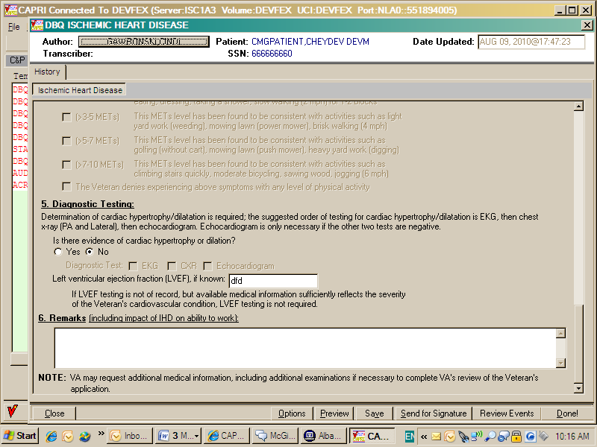

Figure 2: Print Example: DBQ – Standard VA Note

NOTE: VA may request additional medical information, including additional

examinations if necessary to complete VA's review of the Veteran's application.

A number of fields on the Kidney Conditions (Nephrology) template are mandatory and require a response (value) prior to the exam being marked as completed. Some questions may activate a Pop-up window displaying information as to each question that needs to be answered before the template can be completed.

Kidney Conditions (Nephrology) DBQ

Name of patient/Veteran
All questions in this section may be answered as described by the rules below. If all mandatory questions are not answered, the error message(s) will appear in a popup window as depicted below.

Table 1: Rules: DBQ – Kidney Conditions (Nephrology) – Name of patient/Veteran
Field/Question | Field Disposition | Valid Values | Format | Error Message
Kidney Conditions (Nephrology) | Enabled, Read-Only | N/A | N/A | N/A
Disability Benefits Questionnaire | Enabled, Read-Only | N/A | N/A | N/A
Name of patient/Veteran: | Enabled, Mandatory | N/A | Free Text | Please enter the name of the patient/Veteran.
Your patient is applying to the U. S. Department of Veterans Affairs (VA) for disability benefits. VA will consider the information you provide on this questionnaire as part of their evaluation in processing the Veteran’s claim. | Enabled, Read-Only | N/A | N/A | N/A

Figure 3: Template Example: DBQ – Kidney Conditions (Nephrology) – Name of patient/Veteran
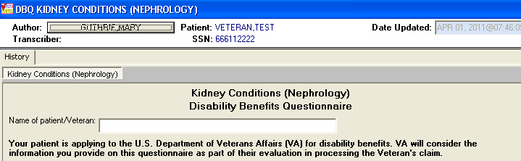

Figure 4: Print Example: DBQ – Kidney Conditions (Nephrology) – Name of patient/Veteran
Kidney Conditions (Nephrology)
Disability Benefits Questionnaire
Name of patient/Veteran:
Your patient is applying to the U.S. Department of Veterans Affairs (VA) for
disability benefits. VA will consider the information you provide on this
questionnaire as part of their evaluation in processing the Veteran's claim.

Section 1. Diagnosis
The question “Does the Veteran now have or has he/she ever been diagnosed with a kidney condition?” must be answered before the template can be completed.
- If it is answered with Yes, all other questions requiring an answer as described by the rules in this document must be answered before the template can be completed.
- If it is answered with No, the rationale is required. The remainder of the template may be completed without answering any additional questions or the user may input answers to any of the optional questions as indicated by the rules described in this document.

All questions will be printed even if they have not been answered.

If all mandatory questions are not answered, the error message(s) will appear in a popup window as depicted below and must be answered before this template can be completed.

Table 2: Rules: DBQ – Kidney Conditions (Nephrology) – 1. Diagnosis
Field/Question | Field Disposition | Valid Values | Format | Error Message
1.Diagnosis | Enabled, Read-Only | N/A | N/A | N/A
Does the Veteran now have or has he/she ever been diagnosed with a kidney condition? | Enabled, Mandatory; Choose one valid value | [Yes; No] | N/A | Please answer the question: Does the Veteran now have or has he ever been diagnosed with a kidney condition?
If no, provide rationale (e.g. Veteran does not currently have any known kidney condition(s)): | If Does the Veteran now have or has he/she ever been diagnosed with a kidney condition? = No; Enabled, Mandatory  Else; Disabled | N/A | Free Text | Please provide the rationale for indicating the Veteran has not been diagnosed with a kidney condition.
If yes, indicate diagnoses: (check all that apply) | If Does the Veteran now have or has he/she ever been diagnosed with a kidney condition? = Yes; Enabled, Mandatory, Choose one or more valid values.  Else; Optional | [Diabetic nephropathy; Glomerulonephritis; Hydronephrosis; Interstitial nephritis; Kidney transplant; Nephrosclerosis; Nephrolithiasis; Renal artery stenosis; Ureterolithiasis; Neoplasm of the kidney; Other kidney condition(specify diagnosis, providing only diagnoses that pertain to kidney conditions.)] | N/A | Please select at least one diagnosis.
ICD Code: | If Diagnosis = Yes and if Diagnosis includes Diabetic nephropathy; Enabled, Mandatory  If Diagnosis = No and if Diagnosis includes Diabetic nephropathy; Enabled, Optional  Else; Disabled | N/A | Free Text | Please enter the ICD code for Diabetic nephropathy.
Date of Diagnosis: | If Diagnosis = Yes and if Diagnosis includes Diabetic nephropathy; Enabled, Mandatory | N/A | Free Text | Please enter the date of diagnosis for Diabetic nephropathy.
ICD Code: | If Diagnosis = Yes and if Diagnosis includes Glomerulonephritis; Enabled, Mandatory  If Diagnosis = No and if Diagnosis includes Glomerulonephritis; Enabled, Optional  Else; Disabled | N/A | Free Text | Please enter the ICD code for Glomerulonephritis.
Date of Diagnosis: | If Diagnosis = Yes and if Diagnosis includes Glomerulonephritis; Enabled, Mandatory  If Diagnosis = No and if Diagnosis includes Glomerulonephritis; Enabled, Optional  Else; Disabled | N/A | Free Text | Please enter the date of diagnosis for Glomerulonephritis.
ICD Code: | If Diagnosis = Yes and if Diagnosis includes Hydronephrosis; Enabled, Mandatory  If Diagnosis = No and if Diagnosis includes Hydronephrosis; Enabled, Optional  Else; Disabled | N/A | Free Text | Please enter the ICD code for Hydronephrosis.
Date of Diagnosis: | If Diagnosis = Yes and if Diagnosis includes Hydronephrosis; Enabled, Mandatory  If Diagnosis = No and if Diagnosis includes Hydronephrosis; Enabled, Optional  Else; Disabled | N/A | Free Text | Please enter the date of diagnosis for Hydronephrosis.
ICD Code: | If Diagnosis = Yes and if Diagnosis includes Interstitial nephritis; Enabled, Mandatory  If Diagnosis = No and if Diagnosis includes Interstitial nephritis; Enabled, Optional  Else; Disabled | N/A | Free Text | Please enter the ICD code for Interstitial nephritis.
Date of Diagnosis: | If Diagnosis = Yes and if Diagnosis includes Interstitial nephritis; Enabled, Mandatory  If Diagnosis = No and if Diagnosis includes Interstitial nephritis; Enabled, Optional  Else; Disabled | N/A | Free Text | Please enter the date of diagnosis for Interstitial nephritis.
ICD Code: | If Diagnosis = Yes and if Diagnosis includes Kidney transplant; Enabled, Mandatory  If Diagnosis = No and if Diagnosis includes Kidney transplant; Enabled, Optional  Else; Disabled | N/A | Free Text | Please enter the ICD code for Kidney transplant.
Date of Diagnosis: | If Diagnosis = Yes and if Diagnosis includes Kidney transplant; Enabled, Mandatory  If Diagnosis = No and if Diagnosis includes Kidney transplant; Enabled, Optional  Else; Disabled | N/A | Free Text | Please enter the date of diagnosis for Kidney transplant.
ICD Code: | If Diagnosis = Yes and if Diagnosis includes Nephrosclerosis; Enabled, Mandatory  If Diagnosis = No and if Diagnosis includes Nephrosclerosis; Enabled, Optional  Else; Disabled | N/A | Free Text | Please enter the ICD code for Nephrosclerosis.
Date of Diagnosis: | If Diagnosis = Yes and if Diagnosis includes Nephrosclerosis; Enabled, Mandatory  If Diagnosis = No and if Diagnosis includes Nephrosclerosis; Enabled, Optional  Else; Disabled | N/A | Free Text | Please enter the date of diagnosis for Nephrosclerosis.
ICD Code: | If Diagnosis = Yes and if Diagnosis includes Nephrolithiasis; Enabled, Mandatory  If Diagnosis = No and if Diagnosis includes Nephrolithiasis; Enabled, Optional  Else; Disabled | N/A | Free Text | Please enter the ICD code for Nephrolithiasis.
Date of Diagnosis: | If Diagnosis = Yes and if Diagnosis includes Nephrolithiasis; Enabled, Mandatory  If Diagnosis = No and if Diagnosis includes Nephrolithiasis; Enabled, Optional  Else; Disabled | N/A | Free Text | Please enter the date of diagnosis for Nephrolithiasis.
ICD Code: | If Diagnosis = Yes and if Diagnosis includes Renal artery stenosis; Enabled, Mandatory  If Diagnosis = No and if Diagnosis includes Renal artery stenosis; Enabled, Optional  Else; Disabled | N/A | Free Text | Please enter the ICD code for Renal artery stenosis.
Date of Diagnosis: | If Diagnosis = Yes and if Diagnosis includes Renal artery stenosis; Enabled, Mandatory  If Diagnosis = No and if Diagnosis includes Renal artery stenosis; Enabled, Optional  Else; Disabled | N/A | Free Text | Please enter the date of diagnosis for Renal artery stenosis.
ICD Code: | If Diagnosis = Yes and if Diagnosis includes Ureterolithiasis; Enabled, Mandatory  If Diagnosis = No and if Diagnosis includes Ureterolithiasis; Enabled, Optional  Else; Disabled | N/A | Free Text | Please enter the ICD code for Ureterolithiasis.
Date of Diagnosis: | If Diagnosis = Yes and if Diagnosis includes Ureterolithiasis; Enabled, Mandatory  If Diagnosis = No and if Diagnosis includes Ureterolithiasis; Enabled, Optional  Else; Disabled | N/A | Free Text | Please enter the date of diagnosis for Ureterolithiasis.
ICD Code: | If Diagnosis = Yes and if Diagnosis includes Neoplasm of the kidney; Enabled, Mandatory  If Diagnosis = No and if Diagnosis includes Neoplasm of the kidney; Enabled, Optional  Else; Disabled | N/A | Free Text | Please enter the ICD code for Neoplasm of the kidney.
Date of Diagnosis: | If Diagnosis = Yes and if Diagnosis includes Neoplasm of the kidney; Enabled, Mandatory  If Diagnosis = No and if Diagnosis includes Neoplasm of the kidney; Enabled, Optional  Else; Disabled | N/A | Free Text | Please enter the date of diagnosis for Neoplasm of the kidney.
Other diagnosis #1: | If Diagnosis includes Other kidney condition;  Enabled; Mandatory  Else; Disabled | N/A | N/A | Please enter a value in the ‘Other diagnosis #1’ field.
ICD code: | If Other diagnosis #1 is populated; Enabled, Mandatory  Else; Disabled | N/A | Free Text | Please enter the ICD code for other diagnosis #1.
Date of diagnosis: | If Other diagnosis #1 is populated; Enabled, Mandatory  Else; Disabled | N/A | Free Text | Please enter the date of other diagnosis #1.
Other diagnosis #2 | If Diagnosis includes Other kidney condition;  Enabled; Optional  Else; Disabled | N/A | N/A | N/A
ICD code: | If Other diagnosis #2 is populated; Enabled, Mandatory  Else; Disabled | N/A | Free Text | Please enter the ICD code for other diagnosis #2.
Date of diagnosis: | If Other diagnosis #2 is populated; Enabled, Mandatory  Else; Disabled | N/A | Free Text | Please enter the date diagnosis for other diagnosis #2.
If there are additional diagnoses that pertain to kidney conditions(s), list using above format: | Enabled, Optional | N/A | Free Text | N/A

Figure 5: Template Example: DBQ – Kidney Conditions (Nephrology) – 1. Diagnosis
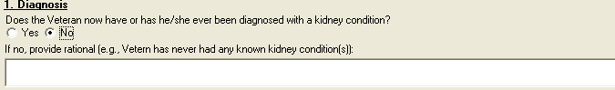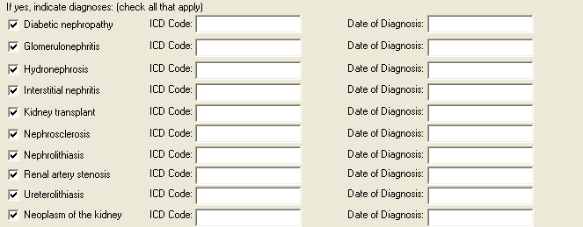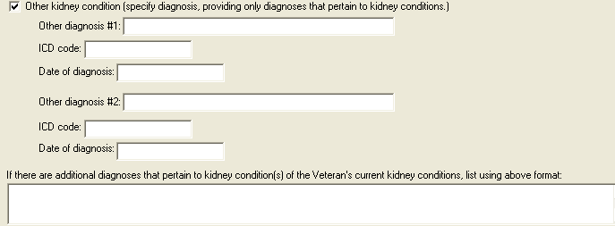

Figure 6: Print Example: DBQ – Kidney Conditions (Nephrology) – 1. Diagnosis
1. Diagnosis
------------
Does the Veteran now have or has he/she ever been diagnosed with a kidney
condition? [X] Yes [ ] No
If no, provide rationale (e.g., Veteran has never had any known kidney
condition(s)):
If yes, indicate diagnoses: (check all that apply)
[ ] Diabetic nephropathy
ICD Code: Date of Diagnosis:
[X] Glomerulonephritis
ICD Code: Date of Diagnosis:
[ ] Hydronephrosis
ICD Code: Date of Diagnosis:
[ ] Interstitial nephritis
ICD Code: Date of Diagnosis:
[ ] Kidney transplant
ICD Code: Date of Diagnosis:
[ ] Nephrosclerosis
ICD Code: Date of Diagnosis:
[ ] Nephrolithiasis
ICD Code: Date of Diagnosis:
[ ] Renal artery stenosis
ICD Code: Date of Diagnosis:
[ ] Ureterolithiasis
ICD Code: Date of Diagnosis:
[ ] Neoplasm of the kidney
ICD Code: Date of Diagnosis:
[X] Other kidney condition (specify diagnosis, providing only diagnoses
that pertain to kidney conditions.)
Other diagnosis #1:
ICD code:
Date of diagnosis:
Other diagnosis #2: a
ICD code:
Date of diagnosis:
If there are additional diagnoses that pertain to kidney conditions,
list using above format:

Section 2. Medical History
All questions in this section may be answered as described by the rules below. If all mandatory questions are not answered, the error message(s) will appear in a popup window as depicted below.

Table 3: Rules: DBQ – Kidney Conditions (Nephrology) – 2. Medical History
Field/Question | Field Disposition | Valid Values | Format | Error Message
2.Medical History | Enabled; Read Only | N/A | N/A | N/A
Describe the history (including cause, onset and course) of the Veteran’s kidney condition: | If Diagnosis = Yes and at least one diagnosis is selected in the Diagnosis section; Enabled, Mandatory  Else; Enabled, Optional | N/A | Free Text | Please describe the history (including onset and course) of the Veteran's kidney condition.

Figure 7: Template Example: DBQ – Kidney Conditions (Nephrology) – 2. Medical History
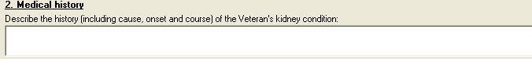

Figure 8: Print Example: DBQ – Kidney Conditions (Nephrology) – 2. Medical History
2. Medical history
------------------
Describe the history (including cause, onset and course) of the Veteran's
kidney condition:

Section 3. Renal dysfunction
All questions in this section may be answered as described by the rules below. If all mandatory questions are not answered, the error message(s) will appear in a popup window as depicted below.

Table 4: Rules: DBQ – Kidney Conditions (Nephrology) – 3. Renal dysfunction
Field/Question | Field Disposition | Valid Values | Format | Error Message
3.Renal dysfunction | Enabled; Read Only | N/A | N/A | N/A
a. Does the Veteran have renal dysfunction? | If Diagnosis = Yes and at least one diagnosis is selected in the Diagnosis section; Enabled, Mandatory, Choose one valid value  Else; Enabled, Optional | [Yes; No] | N/A | Please provide an answer to the question: Does the Veteran have renal dysfunction?
If yes, does the Veteran require regular dialysis? | If Does the Veteran have real dysfunction? = Yes; Enabled; Mandatory; Choose one valid value  Else; Disabled | [Yes; No] | N/A | Please answer whether or not the Veteran requires regular dialysis.
b. Does the Veteran have any signs or symptoms due to renal dysfunction? | If Does the Veteran have renal dysfunction? = Yes; Enabled, Mandatory, Choose one valid value  Else; Disabled | [Yes; No] | N/A | Please provide an answer to the question: Does the Veteran have any signs or symptoms due to renal dysfunction?
If yes, check all that apply: | If Does the Veteran have renal dysfunction? = Yes; Enabled; Optional;  If Does the Veteran have any signs or symptoms due to renal dysfunction? = Yes; Enabled; Mandatory;  Choose one or more valid values  Else; Disabled | [Proteinuria (albuminuria); Edema (due to renal dysfunction); Anorexia (due to renal dysfunction); Weight loss (due to renal dysfunction); Generalized poor health due to renal dysfunction; Lethargy due to renal dysfunction; Weakness due to renal dysfunction; Limitation of exertion due to renal dysfunction; Able to perform only sedentary activity, due to persistent edema caused by renal dysfunction; Markedly decreased function other organ systems, especially the cardiovascular system, caused by renal dysfunction] | N/A | Please select all applicable renal dysfunction related signs or symptoms.
If checked, indicate frequency: (check all that apply) | If Does the Veteran have any signs or symptoms due to renal dysfunction? = Yes and if Renal dysfunction signs or symptoms include Proteinuria (albuminuria); Enabled; Mandatory;  If Does the Veteran have any signs or symptoms due to renal dysfunction? Is not populated and if Renal dysfunction signs or symptoms include Proteinuria (albuminuria);Enabled; Optional;  Choose one or more valid values  Else; Disabled | [Recurring; Constant; Persistent] | N/A | Please indicate the frequency of Proteinuria (albuminuria).
If checked, indicate frequency: (check all that apply) | If Does the Veteran have any signs or symptoms due to renal dysfunction? = Yes and if Renal dysfunction signs or symptoms include Edema (due to renal dysfunction); Enabled; Mandatory;  If Does the Veteran have any signs or symptoms due to renal dysfunction? is not populated and if Renal dysfunction signs or symptoms include Edema (due to renal dysfunction); Enabled; Optional;  Choose one or more valid values  Else; Disabled | [Some; Transient; Slight; Persistent] | N/A | Please indicate the frequency of edema (due to renal dysfunction).
If checked, provide baseline weight (average weight for 2-year period preceding onset of disease): | If Does the Veteran have any signs or symptoms due to renal dysfunction? = Yes and if Renal dysfunction signs or symptoms include Weight loss (due to renal dysfunction); Enabled; Mandatory;  If Does the Veteran have any signs or symptoms due to renal dysfunction? Is not populated and if Renal dysfunction signs or symptoms include Weight loss (due to renal dysfunction); Enabled; Optional;  Choose one or more valid values  Else; Disabled | N/A | Free Text | Please provide the baseline weight.
Provide current weight: | If Does the Veteran have any signs or symptoms due to renal dysfunction? = Yes and if Renal dysfunction signs or symptoms include Weight loss (due to renal dysfunction); Enabled; Mandatory;  If Does the Veteran have any signs or symptoms due to renal dysfunction? is not populated and if Renal dysfunction signs or symptoms include Weight loss (due to renal dysfunction); Enabled; Optional;  Choose one or more valid values  Else; Disabled | N/A | Free Text | Please provide the current weight.
If checked, describe: | If Does the Veteran have any signs or symptoms due to renal dysfunction? = Yes and if Renal dysfunction signs or symptoms include Markedly decreased function other organ systems, especially the cardiovascular system, caused by renal dysfunction; Enabled; Mandatory;  If Does the Veteran have any signs or symptoms due to renal dysfunction? is not populated and if Renal dysfunction signs or symptoms include Markedly decreased function other organ systems, especially the cardiovascular system, caused by renal dysfunction; Enabled; Optional;  Choose one or more valid values  Else; Disabled | N/A | Free Text | Please describe the decreased function of other organ systems caused by renal dysfunction.
c. Does the Veteran have hypertension and/or heart disease due to renal dysfunction or caused by any kidney condition? | If Diagnosis = Yes and at least one diagnosis is selected in the Diagnosis section and Does the Veteran have renal dysfunction = Yes; Enabled, Mandatory, Choose one valid value  Else; Enabled, Optional | [Yes; No] | N/A | Please provide an answer to the question: Does the Veteran have hypertension and/or heart disease due to renal dysfunction or caused by any kidney condition?
If yes, also complete the Hypertension and/or Heart Disease Questionnaire as appropriate. | If Does the Veteran have hypertension and/or heart disease due to renal dysfunction or caused by any kidney condition? = Yes; Enabled; Read-Only  Else; Disabled | N/A | N/A | N/A

Figure 9: Template Example: DBQ – Kidney Conditions (Nephrology) – 3. Renal dysfunction
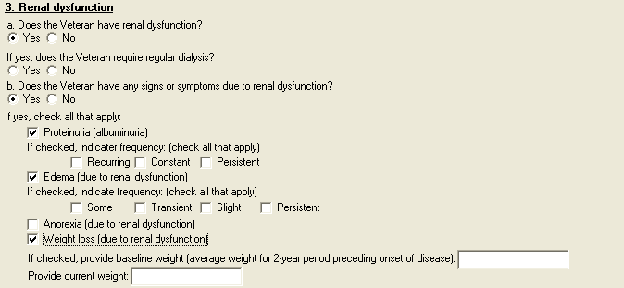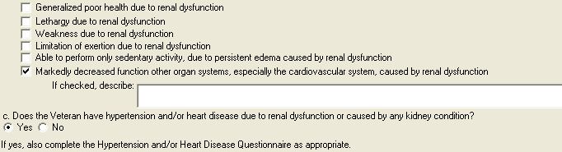

Figure 10: Print Example: DBQ – Kidney Conditions (Nephrology) – 3. Renal dysfunction
3. Renal dysfunction
--------------------
a. Does the Veteran have renal dysfunction?
[X] Yes [ ] No
If yes, does the Veteran require regular dialysis?
[X] Yes [ ] No
b. Does the Veteran have any signs or symptoms due to renal dysfunction?
[X] Yes [ ] No
If yes, check all that apply:
[ ] Proteinuria (albuminuria)
If checked, indicate frequency: (check all that apply)
[ ] Recurring [ ] Constant [ ] Persistent
[ ] Edema (due to renal dysfunction)
If checked, indicate frequency: (check all that apply)
[ ] Some [ ] Transient [ ] Slight [ ] Persistent
[ ] Anorexia (due to renal dysfunction)
[ ] Weight loss (due to renal dysfunction)
If checked, provide baseline weight (average weight for 2-year
period preceding onset of disease):
Provide current weight:
[ ] Generalized poor health due to renal dysfunction
[ ] Lethargy due to renal dysfunction
[ ] Weakness due to renal dysfunction
[ ] Limitation of exertion due to renal dysfunction
[X] Able to perform only sedentary activity, due to persistent
edema caused by renal dysfunction
[X] Markedly decreased function other organ systems, especially
the cardiovascular system, caused by renal dysfunction
If checked, describe:
c. Does the Veteran have hypertension and/or heart disease due to renal
dysfunction or caused by any kidney condition?
[X] Yes [ ] No
If yes, also complete the Hypertension and/or Heart Disease Questionnaire
as appropriate.

Section 4. Urolithiasis
All questions in this section may be answered as described by the rules below. If all mandatory questions are not answered, the error message(s) will appear in a popup window as depicted below.

Table 5: Rules: DBQ – Kidney Conditions (Nephrology) – 4. Urolithiasis
Field/Question | Field Disposition | Valid Values | Format | Error Message
4. Urolithiasis | Enabled, Read-Only | N/A | N/A | N/A
a. Does the Veteran have kidney, ureteral or bladder calculi? | If Diagnosis = Yes and at least one diagnosis is selected in the Diagnosis section; Enabled, Mandatory, Choose one valid value  Else; Enabled, Optional | [Yes; No] | N/A | Please provide an answer to the question: Does the Veteran have kidney, ureteral or bladder calculi?
If yes, indicate location (check all that apply) | If Does the Veteran have kidney, ureteral or bladder calculi? = Yes; Enabled; Mandatory, Choose one or more valid values  Else; Disabled | [Kidney; Ureter; Bladder] | N/A | Please select all locations where calculi are found.
If the Veteran has urolithiasis, complete the following: | If Does the Veteran have kidney, ureteral or bladder calculi? = Yes; Enabled; Read-Only  Else; Disabled | N/A | N/A | N/A
b. Has the Veteran had treatment for recurrent stone formation in the kidney, ureter or bladder? | If Does the Veteran have kidney, ureteral or bladder calculi? = Yes; Enabled; Mandatory, Choose one valid value  Else; Disabled | [Yes; No] | N/A | Please provide an answer to the question: Has the Veteran had treatment for recurrent stone formation in the kidney, ureter or bladder?
If yes, indicate treatment: (check all that apply) | If Has the Veteran had treatment for recurrent stone formation in the kidney, ureter or bladder? = Yes; Enabled; Mandatory; Choose one or more valid values  Else; Disabled | [Diet therapy; Drug therapy; Invasive or non-invasive procedures] | N/A | Please select at least one treatment for recurrent stone formation in the kidney, ureter or bladder.
If checked, specify diet and dates of use: | If treatment includes Diet therapy; Enabled; Mandatory  Else; Disabled | N/A | Free Text | Please specify the diet and dates of use.
If checked, list medication and dates of use: | If treatment includes Drug therapy; Enabled; Mandatory  Else; Disabled | N/A | Free Text | Please list the medication and dates of use.
If checked, indicate average number of times per year invasive or non-invasive procedures were required: | If treatment includes Invasive or non-invasive procedures; Enabled; Mandatory; Choose one valid value  Else; Disabled | [0 to 1 per year; 2 per year; >2 per year] | N/A | Please indicate the average number of times per year invasive or non-invasive procedures were required for treatment of urolithiasis.
Date and facility of most recent invasive or non-invasive procedure: | If treatment includes Invasive or non-invasive procedures; Enabled; Mandatory  Else; Disabled | N/A | Free Text | Please enter the date of the most recent invasive or non-invasive procedure for treatment of urolithiasis, and the facility where it was performed.
c. Does the Veteran have signs or symptoms due to urolithiasis? | If Diagnosis = Yes; Enabled, Mandatory, Choose one valid value  Else; Enabled, Optional | [Yes; No] | N/A | Please provide an answer to the question: Does the Veteran have signs or symptoms due to urolithiasis?
If yes, indicate severity (check all that apply): | If Does the Veteran have signs or symptoms due to urolithiasis? = Yes; Enabled; Mandatory; Choose one or more valid values  Else; Disabled | [No symptoms or attacks of colic; Occasional attacks of colic; Frequent attacks of colic; Causing voiding dysfunction; Requires catheter drainage; Causing infection (pyonephrosis); Causing hydronephrosis; Causing impaired kidney function; Other, describe:] | N/A | Please check one or more signs or symptoms due to urolithiasis.
Other, describe: | If severity includes Other; Enabled; Mandatory  Else; Disabled | N/A | Free Text | Please describe the other signs or symptoms due to urolithiasis.

Figure 11: Template Example: DBQ – Kidney Conditions (Nephrology) – 4. Urolithiasis
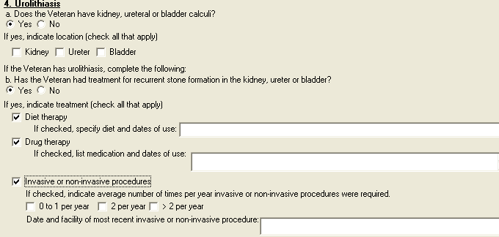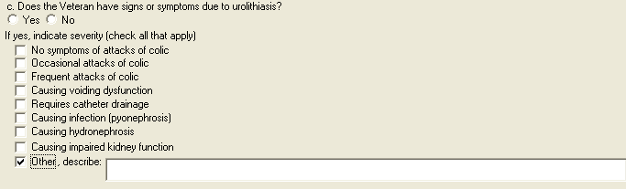

Figure 12: Print Example: DBQ – Kidney Conditions (Nephrology) – 4. Urolithiasis
4. Urolithiasis
---------------
a. Does the Veteran have kidney, ureteral or bladder calculi?
[ ] Yes [ ] No
If yes, indicate location (check all that apply)
[ ] Kidney [ ] Ureter [ ] Bladder
If the Veteran has urolithiasis, complete the following:
b. Has the Veteran had treatment for recurrent stone formation in the
kidney, ureter or bladder?
[ ] Yes [ ] No
If yes, indicate treatment (check all that apply)
[ ] Diet therapy
If checked, specify diet and dates of use:
[ ] Drug therapy
If checked, list medication and dates of use:
[ ] Invasive or non-invasive procedures:
If checked, indicate average number of times per year invasive
or non-invasive procedures were required:
[ ] 0 to 1 per year [ ] 2 per year [ ] > 2 per year
Date and facility of most recent invasive or non-invasive
procedure:
c. Does the Veteran have signs or symptoms due to urolithiasis?
[ ] Yes [ ] No
If yes, indicate severity (check all that apply)
[ ] No symptoms or attacks of colic
[ ] Occasional attacks of colic
[ ] Frequent attacks of colic
[ ] Causing voiding dysfunction
[ ] Requires catheter drainage
[ ] Causing infection (pyonephrosis)
[ ] Causing hydronephrosis
[ ] Causing impaired kidney function
[ ] Other, describe:

Section 5. Urinary tract/kidney infection
All questions in this section may be answered as described by the rules below. If all mandatory questions are not answered, the error message(s) will appear in a popup window as depicted below.

Table 6: Rules: DBQ – Kidney Conditions (Nephrology) – 5. Urinary tract/kidney infection
Field/Question | Field Disposition | Valid Values | Format | Error Message
5. Urinary tract/kidney infection | Enabled; Read-Only | N/A | N/A | N/A
Does the Veteran have a history of recurrent symptomatic urinary tract or kidney infections? | If Diagnosis = Yes and at least one diagnosis is selected in the Diagnosis section; Enabled, Mandatory, Choose one valid value  Else; Enabled, Optional | [Yes; No] | N/A | Please answer the question: Does the Veteran have a history of recurrent symptomatic urinary tract or kidney infections?
If yes, provide etiology: | If Does the Veteran have a history of recurrent symptomatic urinary tract or kidney infections?= Yes; Enabled; Mandatory  Else; Disabled | N/A | Free Text | Please provide the etiology of the recurrent symptomatic urinary tract or kidney infections.
If the Veteran has had recurrent symptomatic urinary tract or kidney infections, indicate all treatment modalities that apply: | If Does the Veteran have a history of recurrent symptomatic urinary tract or kidney infections?= Yes; Enabled; Mandatory; Choose one or more valid values  Else; Disabled | [No treatment; OR Long-term drug therapy; Hospitalization; Drainage; Continuous intensive management; Intermittent intensive management; Other] | N/A | Please check one or more boxes to indicate applicable treatment modalities for recurrent symptomatic urinary tract or kidney infections.
If checked, list medications used and indicate dates for courses of treatment over the past 12 months: | If treatment modalities include Long-term drug therapy; Enabled; Mandatory  Else Disabled | N/A | Free Text | Please list medications used for urinary tract or kidney infections and their treatment dates over the past 12 months.
If checked, indicate frequency of hospitalization: | If treatment modalities include Hospitalization; Enabled; Mandatory  Else Disabled | [1 or 2 per year; >2 per year] | N/A | Please indicate the frequency of hospitalization.
If checked, indicate dates when drainage performed over past 12 months: | If treatment modalities include Drainage; Enabled; Mandatory  Else Disabled | N/A | Free Text | Please indicate the dates that drainage was performed over the past 12 months.
If checked, indicate types of treatments and medications used over past 12 months: | If treatment modalities include Continuous intensive management; Enabled; Mandatory  Else Disabled | N/A | Free Text | Please describe the types of treatment and medications for continuous intensive management used over the past 12 months.
If checked, indicate types of treatments and medications used over past 12 months: | If treatment modalities include Intermittent intensive management; Enabled; Mandatory  Else Disabled | N/A | Free Text | Please describe the types of treatment and medications for intermittent intensive management used over the past 12 months.
Other, describe: | If treatment modalities include Other; Enabled; Mandatory  Else Disabled | N/A | Free Text | Please describe other treatment modalities used for urinary tract or kidney infections.

Figure 13: Template Example: DBQ – Kidney Conditions (Nephrology) – 5. Urinary tract/kidney infection
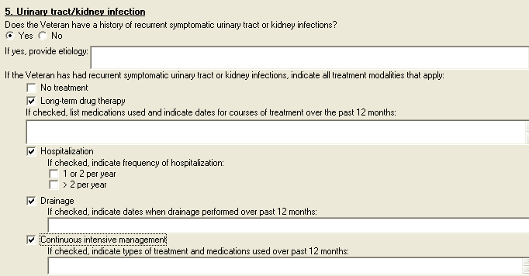
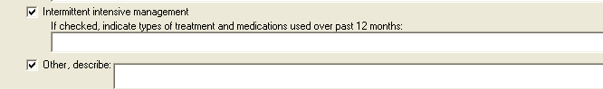

Figure 14: Print Example: DBQ – Kidney Conditions (Nephrology) – 5. Urinary tract/kidney infection
5. Urinary tract/kidney infection
---------------------------------
Does the Veteran have a history of recurrent symptomatic urinary tract or
kidney infections?
[ ] Yes [ ] No
If yes, provide etiology:
If the Veteran has had recurrent symptomatic urinary tract or kidney
infections, indicate all treatment modalities that apply:
[ ] No treatment
[ ] Long-term drug therapy
If checked, list medications used and indicate dates courses
for treatment over the past 12 months:
[ ] Hospitalization
If checked, indicate frequency of hospitalization:
[ ] 1 or 2 per year
[ ] > 2 per year
[ ] Drainage
If checked, indicate dates when drainage performed over past
12 months:
[ ] Continuous intensive management
If checked, indicate types of treatment and medications used
over past 12 months:
[ ] Intermittent intensive management
If checked, indicate types of treatment and medications used
over past 12 months:
[ ] Other, describe:

Section 6. Kidney transplant or removal

All questions in this section may be answered as described by the rules below. If all mandatory questions are not answered, the error message(s) will appear in a popup window as depicted below.

Table 7: Rules: DBQ – Kidney Conditions (Nephrology) – 6. Kidney transplant or removal
Field/Question | Field Disposition | Valid Values | Format | Error Message
6. Kidney transplant or removal | Enabled, Read-Only | N/A | N/A | N/A
a. Has the Veteran had a kidney removed? | If Diagnosis = Yes and at least one diagnosis is selected in the Diagnosis section; Enabled, Mandatory, Choose one valid value  Else; Enabled, Optional | [Yes; No] | N/A | Please provide an answer to the question: Has the Veteran had a kidney removed?
If yes, provide reason: | If Has the Veteran had a kidney removed? = Yes; Enabled; Mandatory  Else; Disabled | [Kidney donation; Due to disease; Due to trauma or injury; Other, describe:] | N/A | Please provide the reason a kidney was removed.
Other, describe: | If Reason = Other; Enabled; Mandatory | N/A | Free Text | Please describe the other reason a kidney was removed.
b. Has the Veteran had a kidney transplant? | If Diagnosis = Yes; Enabled, Mandatory, Choose one valid value  Else; Enabled, Optional | [Yes; No] | N/A | Please provide an answer to the question: Has the Veteran had a kidney transplant?
If yes, date of admission: | If Has the Veteran had a kidney transplant? = Yes; Enabled; Mandatory  Else; Disabled | N/A | Free Text | Please enter the date of admission of the kidney transplant.
Date of discharge: | If Has the Veteran had a kidney transplant? = Yes; Enabled; Mandatory  Else; Disabled | N/A | Free Text | Please enter the date of discharge of the kidney transplant.

Figure 15: Template Example: DBQ – Kidney Conditions (Nephrology) – 6. Kidney transplant or removal
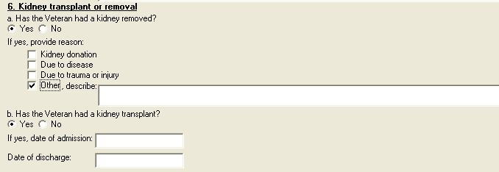

Figure 16: Print Example: DBQ – Kidney Conditions (Nephrology) – 6. Kidney transplant or removal
6. Kidney transplant or removal
-------------------------------
a. Has the Veteran had a kidney removed?
[ ] Yes [ ] No
If yes, provide reason:
[ ] Kidney donation
[ ] Due to disease
[ ] Due to trauma or injury
[ ] Other, describe:
b. Has the Veteran had a kidney transplant?
[ ] Yes [ ] No
If yes, date of admission:
Date of discharge:

Section 7. Tumors and Neoplasms
All questions in this section may be answered as described by the rules below. If all mandatory questions are not answered, the error message(s) will appear in a popup window as depicted below.

Table 8: Rules: DBQ – Kidney Conditions (Nephrology) – 7. Tumors and Neoplasms
Field/Question | Field Disposition | Valid Values | Format | Error Message
7. Tumors and Neoplasms | Enabled, Read-Only | N/A | N/A | N/A
a. Does the Veteran have a benign or malignant neoplasm or metastases related to any of the diagnoses in the Diagnosis section? | If Diagnosis = Yes and at least one diagnosis is selected in the Diagnosis section; Enabled, Mandatory, Choose one valid value  Else; Enabled, Optional | [Yes; No] | N/A | Please provide an answer to the question: Does the Veteran have a benign or malignant neoplasm or metastases related to any of the diagnoses in the Diagnosis section?
If yes, complete the following: | If Does the Veteran have a benign or malignant neoplasm or metastases related to any of the diagnoses in the Diagnosis section? = Yes; Enabled; Read-Only  Else; Disabled | N/A | N/A | N/A
b. Is the neoplasm | If Does the Veteran have a benign or malignant neoplasm or metastases related to any of the diagnoses in the Diagnosis section? = Yes; Enabled; Mandatory, Choose one valid value  Else; Disabled | [Benign; Malignant] | N/A | Please indicate whether the neoplasm is benign or malignant.
c. Has the Veteran completed treatment or is the Veteran currently undergoing treatment for a benign or malignant neoplasm or metastases? | If Does the Veteran have a benign or malignant neoplasm or metastases related to any of the diagnoses in the Diagnosis section? = Yes; Enabled; Mandatory, Choose one valid value  Else; Disabled | [Yes; No, watchful waiting] | N/A | Please provide an answer to the question: Has the Veteran completed treatment or is the Veteran currently undergoing treatment for a benign or malignant neoplasm or metastases?
If yes, indicate type of treatment the Veteran is currently undergoing or has completed (check all that apply): | If Has the Veteran completed treatment or is the Veteran currently undergoing treatment for a benign or malignant neoplasm or metastases? = Yes; Enabled, Mandatory, Choose one or more valid values  Else; Disabled | [Treatment completed; currently in watchful waiting status; Surgery; Radiation therapy; Antineoplastic chemotherapy; Other therapeutic procedure; Other therapeutic treatment] | N/A | Please indicate all applicable treatment types for a benign or malignant neoplasm or metastases that the Veteran either is undergoing or has completed.
If checked, describe: | If treatments include Surgery; Enabled, Mandatory  Else; Disabled | N/A | Free Text | Please describe the surgery.
Date(s) of surgery: | If treatments include Surgery; Enabled, Mandatory  Else; Disabled | N/A | Free Text | Please enter the date(s) of surgery.
Date of most recent treatment: | If treatments include Radiation therapy; Enabled, Mandatory  Else; Disabled | N/A | Free Text | Please enter the date of the most recent radiation therapy treatment.
Date of completion of treatment or anticipated date of completion: | If treatments include Radiation therapy; Enabled, Mandatory  Else; Disabled | N/A | Free Text | Please enter the date (actual or anticipated) of completion of the radiation therapy treatment.
Date of most recent treatment: | If treatments include Antineoplastic chemotherapy; Enabled, Mandatory  Else; Disabled | N/A | Free Text | Please enter the date of the most recent antineoplastic chemotherapy treatment.
Date of completion of treatment or anticipated date of completion: | If treatments include Antineoplastic chemotherapy; Enabled, Mandatory  Else; Disabled | N/A | Free Text | Please enter the date (actual or anticipated) of the most recent antineoplastic chemotherapy treatment.
If checked, describe procedure: | If treatments include Other therapeutic procedure; Enabled, Mandatory  Else; Disabled | N/A | Free Text | Please describe the other therapeutic procedure.
Date of most recent procedure: | If treatments include Other therapeutic procedure; Enabled, Mandatory  Else; Disabled | N/A | Free Text | Please enter the date of the most recent other therapeutic procedure.
If checked, describe treatment: | If treatments include Other therapeutic treatment; Enabled, Mandatory  Else; Disabled | N/A | Free Text | Please describe the other therapeutic treatment.
Date of completion of treatment or anticipated date of completion: | If treatments include Other therapeutic treatment; Enabled, Mandatory  Else; Disabled | N/A | Free Text | Please enter the date (actual or anticipated) of completion of the other therapeutic treatment.
d. Does the Veteran currently have any residual conditions or complications due to the neoplasm (including metastases) or its treatment other than those already documented in the report above? | If Does the Veteran have a benign or malignant neoplasm or metastases related to any of the diagnoses in the Diagnosis section? = Yes; Enabled; Mandatory, Choose one valid value  Else; Disabled | [Yes; No] |  | Please indicate whether or not the Veteran has any residual conditions or complications due to the neoplasm (including metastases) or its treatment other than those already documented.
If yes, list residual conditions and complications (brief summary): | If previous question = Yes; Enabled, Mandatory  Else; Disabled | N/A | Free Text | Please list the residual conditions and complications due to the neoplasm (including metastases) or its treatment.
e. If there are additional benign or malignant neoplasms or metastases related to any of the diagnoses in the Diagnosis section, describe using the above format: | If Does the Veteran have a benign or malignant neoplasm or metastases related to any of the diagnoses in the Diagnosis section? = Yes; Enabled; Optional  Else; Disabled | N/A | Free Text | N/A

Figure 17: Template Example: DBQ – Kidney Conditions (Nephrology) – 7. Tumors and Neoplasms
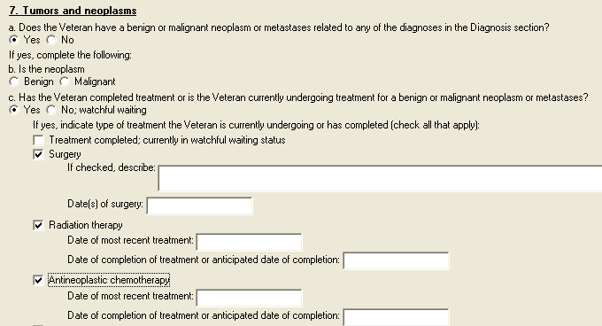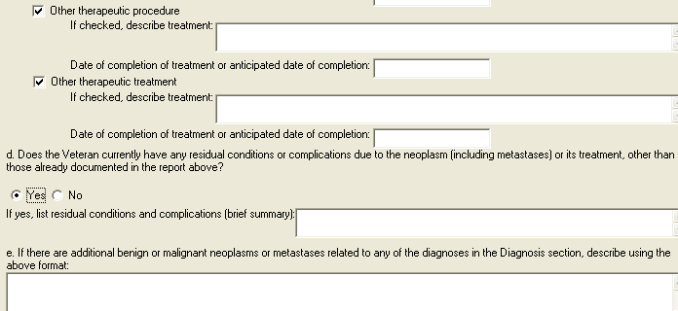

Figure 18: Print Example: DBQ – Kidney Conditions (Nephrology) – 7. Tumors and Neoplasms
7. Tumors and neoplasms
-----------------------
a. Does the Veteran have a benign or malignant neoplasm or metastases
related to any of the diagnoses in the Diagnosis section?
[ ] Yes [ ] No
If yes, complete the following:
b. Is the neoplasm
[ ] Benign [ ] Malignant
c. Has the Veteran completed treatment or is the Veteran currently
undergoing treatment for a benign or malignant neoplasm or metastases?
[ ] Yes [ ] No; watchful waiting
If yes, indicate type of treatment the Veteran is currently undergoing or
has completed (check all that apply):
[ ] Treatment completed; currently in watchful waiting status
[ ] Surgery
If checked, describe:
Date(s) of surgery:
[ ] Radiation therapy
Date of most recent treatment:
Date of completion of treatment or anticipated date of completion:
[ ] Antineoplastic chemotherapy
Date of most recent treatment:
Date of completion of treatment or anticipated date of completion:
[ ] Other therapeutic procedure
If checked, describe procedure:
Date of most recent procedure:
[ ] Other therapeutic treatment
If checked, describe treatment:
Date of completion of treatment or anticipated date of completion:
d. Does the Veteran currently have any residual conditions or complications
due to the neoplasm (including metastases) or its treatment, other than those
already documented in the report above?
[ ] Yes [ ] No
If yes, list residual conditions and complications (brief summary):
e. If there are additional benign or malignant neoplasms or metastases
related to any of the diagnoses in the Diagnosis section, describe using the
above format:

Section 8. Other pertinent physical findings, complications, signs and/or symptoms
All questions in this section may be answered as described by the rules below.

Table 9: Rules: DBQ – Kidney Conditions (Nephrology) – 8. Other pertinent physical findings, complications, signs and/or symptoms
Field/Question | Field Disposition | Valid Values | Format | Error Message
8. Other pertinent physical findings, complications, signs and/or symptoms | Enabled; Read-Only | N/A | N/A | N/A
a. Does the Veteran have any scars (surgical or otherwise) related to any conditions or to the treatment of any conditions listed in the Diagnosis section above? | If Diagnosis = Yes and at least one diagnosis is selected in the Diagnosis section; Enabled, Mandatory, Choose one valid value  Else; Enabled, Optional | [Yes; No] | N/A | Please indicate whether or not the Veteran has any scars (surgical or otherwise) related to any conditions (or their treatment) listed in the Diagnosis section.
If yes, are any of the scars painful and/or unstable, or is the total area of all related scars greater than 39 square cm (6 square inches)? | If previous question = Yes; Enabled, Mandatory, Choose one valid value  Else; Disabled | [Yes; No] | N/A | Please answer whether or not any of the scars are painful and/or unstable, or if the total area of all related scars is greater than 39 square cm (6 square inches).
If yes, also complete a Scars Questionnaire. | If previous question = Yes; Enabled, Read-Only  Else; Disabled | N/A | N/A | N/A
b. Does the Veteran have any other pertinent physical findings, complications, conditions, signs or symptoms? | If Diagnosis = Yes and at least one diagnosis is selected in the Diagnosis section; Enabled, Mandatory, Choose one valid value  Else; Enabled, Optional | [Yes; No] | N/A | Please provide an answer to the question: Does the Veteran have any other pertinent physical findings, complications, conditions, signs or symptoms?
If yes, describe (brief summary): | If Does the Veteran have any other pertinent physical findings, complications, conditions, signs and/or symptoms?= Yes; Enabled; Mandatory  Else; Disabled | N/A | Free Text | Please describe any other pertinent physical findings, complications, conditions, signs or symptoms.

Figure 19: Template Example: DBQ – Kidney Conditions (Nephrology) – 8. Other pertinent physical findings, complications, signs and/or symptoms
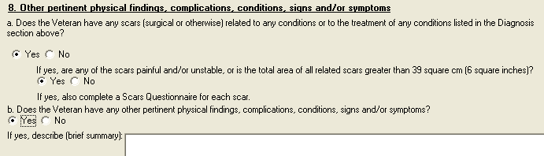

Figure 20: Print Example: DBQ – Kidney Conditions (Nephrology) – 8. Other pertinent physical findings, complications, signs and/or symptoms
8. Other pertinent physical findings, complications, conditions, signs
and/or symptoms
----------------------------------------------------------------------
a. Does the Veteran have any scars (surgical or otherwise) related to any
conditions or to the treatment of any conditions listed in the Diagnosis
section above?
[ ] Yes [ ] No
If yes, are any of the scars painful and/or unstable, or is the total
area of all related scars greater than 39 square cm (6 square inches)?
[ ] Yes [ ] No
If yes, also complete a Scars Questionnaire.
b. Does the Veteran have any other pertinent physical findings,
complications, conditions, signs or symptoms?
[ ] Yes [ ] No
If yes, describe (brief summary):

Section 9. Diagnostic testing
All questions in this section may be answered as described by the rules below.

Table 10: Rules: DBQ – Kidney Conditions (Nephrology) – 9. Diagnostic testing
Field/Question | Field Disposition | Valid Values | Format | Error Message
9. Diagnostic testing | Enabled; Read-Only | N/A | N/A | N/A
NOTE: If laboratory test results are in the medical record and reflect the Veteran’s current renal function, repeat testing is not required. | Enabled; Read-Only | N/A | N/A | N/A
a. Has the Veteran had laboratory or other diagnostic studies performed? | If Diagnosis = Yes and at least one diagnosis is selected in the Diagnosis section; Enabled, Mandatory, Choose one valid value  Else; Enabled, Optional | [Yes; No] | N/A | Please provide an answer to the question: Has the Veteran had laboratory or other diagnostic studies performed?
If yes, provide most recent results, if available: | If Has the Veteran had laboratory or other diagnostic studies performed? = Yes; Enabled; Read-Only  Else; Disabled | N/A | N/A | N/A
b. Laboratory studies | If Has the Veteran had laboratory or other diagnostic studies performed? = Yes; Enabled; Optional; Choose one or more valid values.  Else; Enabled, Optional | [BUN; Creatinine; EGFR] | N/A | N/A
BUN:  Date: | If Has the Veteran had laboratory or other diagnostic studies performed? = Yes and If Laboratory studies include BUN; Enabled; Mandatory  If Has the Veteran had laboratory or other diagnostic studies performed? = No and If Laboratory studies include BUN; Enabled; Optional  Else; Disabled | N/A | Free Text | Please enter the date of the BUN laboratory study.
Result: | If Has the Veteran had laboratory or other diagnostic studies performed? = Yes and If Laboratory studies include BUN; Enabled; Mandatory  If Has the Veteran had laboratory or other diagnostic studies performed? = No and If Laboratory studies include BUN; Enabled; Optional  Else; Disabled | N/A | Free Text | Please enter the result of the BUN laboratory study.
Creatinine:  Date: | If Has the Veteran had laboratory or other diagnostic studies performed? = Yes and If Laboratory studies include Creatinine; Enabled; Mandatory  If Has the Veteran had laboratory or other diagnostic studies performed? = No and If Laboratory studies include Creatinine; Enabled; Optional  Else; Disabled | N/A | Free Text | Please enter the date of the creatinine laboratory study.
Result: | If Has the Veteran had laboratory or other diagnostic studies performed? = Yes and If Laboratory studies include Creatinine; Enabled; Mandatory  If Has the Veteran had laboratory or other diagnostic studies performed? = No and If Laboratory studies include Creatinine; Enabled; Optional | N/A | Free Text | Please enter the result of the creatinine laboratory study.
EGFR:  Date: | If Has the Veteran had laboratory or other diagnostic studies performed? = Yes and If Laboratory studies include EGFR; Enabled; Mandatory  If Has the Veteran had laboratory or other diagnostic studies performed? = No and If Laboratory studies include EGFR; Enabled; Optional  Else; Disabled | N/A | Free Text | Please enter the date of the EGFR laboratory study.
Result: | If Has the Veteran had laboratory or other diagnostic studies performed? = Yes and If Laboratory studies include EGFR; Enabled; Mandatory  If Has the Veteran had laboratory or other diagnostic studies performed? = No and If Laboratory studies include EGFR; Enabled; Optional | N/A | Free Text | Please enter the result of the EGFR laboratory study.
c. Urinalysis: | If Has the Veteran had laboratory or other diagnostic studies performed? = Yes; Enabled; Optional; Choose one or more valid values  Else; Enabled, Optional | [Hyaline casts; Granular casts; RBC’s/HPF; Protein (albumin); Spot urine for protein/creatinine ratio; 24 hour protein (albumin)] | Free Text | N/A
Hyaline casts:  Date | If Has the Veteran had laboratory or other diagnostic studies performed? = Yes and If Urinalysis includes Hyaline casts; Enabled; Mandatory  If Has the Veteran had laboratory or other diagnostic studies performed? = No and If Urinalysis includes Hyaline casts; Enabled; Optional  Else; Disabled | N/A | Free Text | Please enter the date of the hyaline casts urinalysis.
Result: | If Has the Veteran had laboratory or other diagnostic studies performed? = Yes and If Urinalysis includes Hyaline casts; Enabled; Mandatory  If Has the Veteran had laboratory or other diagnostic studies performed? = No and If Urinalysis includes Hyaline casts; Enabled; Optional | N/A | Free Text | Please enter the result of the hyaline casts urinalysis.
Granular casts:  Date: | If Has the Veteran had laboratory or other diagnostic studies performed? = Yes and If Urinalysis includes Granular casts; Enabled; Mandatory  If Has the Veteran had laboratory or other diagnostic studies performed? = No and If Urinalysis includes Granular casts; Enabled; Optional  Else; Disabled | N/A | Free Text | Please enter the date of the granular casts urinalysis.
Result: | If Has the Veteran had laboratory or other diagnostic studies performed? = Yes and If Urinalysis includes Granular casts; Enabled; Mandatory  If Has the Veteran had laboratory or other diagnostic studies performed? = No and If Urinalysis includes Granular casts; Enabled; Optional  Else; Disabled | N/A | Free Text | Please enter the results of the granular casts urinalysis.
RBC’s/HPF:  Date: | If Has the Veteran had laboratory or other diagnostic studies performed? = Yes and If Urinalysis includes RBC’s/HPF; Enabled; Mandatory  If Has the Veteran had laboratory or other diagnostic studies performed? = No and If Urinalysis includes RBC’s/HPF; Enabled; Optional  Else; Disabled | N/A | Free Text | Please enter the date of the RBC’s/HPF urinalysis.
Result: | If Has the Veteran had laboratory or other diagnostic studies performed? = Yes and If Urinalysis includes RBC’s/HPF; Enabled; Mandatory  If Has the Veteran had laboratory or other diagnostic studies performed? = No and If Urinalysis includes RBC’s/HPF; Enabled; Optional  Else; Disabled | N/A | Free Text | Please enter the result of the RBC’s/HPF urinalysis.
Protein (albumin):  Date: | If Has the Veteran had laboratory or other diagnostic studies performed? = Yes and If Urinalysis includes Protein (albumin); Enabled; Mandatory  If Has the Veteran had laboratory or other diagnostic studies performed? = No and If Urinalysis includes Protein (albumin); Enabled; Optional  Else; Disabled | N/A | Free Text | Please enter the date of the protein (albumin) urinalysis.
Result: | If Has the Veteran had laboratory or other diagnostic studies performed? = Yes and If Urinalysis includes Protein (albumin); Enabled; Mandatory  If Has the Veteran had laboratory or other diagnostic studies performed? = No and If Urinalysis includes Protein (albumin); Enabled; Optional  Else; Disabled | N/A | Free Text | Please enter the result of the protein (albumin) urinalysis.
Spot urine for protein/creatinine ratio: Date: | If Has the Veteran had laboratory or other diagnostic studies performed? = Yes and If Urinalysis includes Spot urine for protein/creatinine ratio ;Enabled; Mandatory  If Has the Veteran had laboratory or other diagnostic studies performed? = No and If Urinalysis includes Spot urine for protein/creatinine ratio; Enabled; Optional  Else; Disabled | N/A | Free Text | Please enter the date of spot urine for protein/creatinine ratio urinalysis.
Result: | If Has the Veteran had laboratory or other diagnostic studies performed? = Yes and If Urinalysis includes Spot urine for protein/creatinine ratio; Enabled; Mandatory  If Has the Veteran had laboratory or other diagnostic studies performed? = No and If Urinalysis includes Spot urine for protein/creatinine ratio; Enabled; Optional  Else; Disabled | N/A | Free Text | Please enter the result of spot urine for protein/creatinine ratio urinalysis.
24 hour protein (albumin):  Date: | If Has the Veteran had laboratory or other diagnostic studies performed? = Yes and If Urinalysis includes 24 hour protein (albumin); Enabled; Mandatory  If Has the Veteran had laboratory or other diagnostic studies performed? = No and If Urinalysis includes 24 hour protein (albumin); Enabled; Optional  Else; Disabled | N/A | Free Text | Please enter the date of the 24 hour protein (albumin) urinalysis.
Result: | If Has the Veteran had laboratory or other diagnostic studies performed? = Yes and If Urinalysis includes 24 hour protein (albumin); Enabled; Mandatory  If Has the Veteran had laboratory or other diagnostic studies performed? = No and If Urinalysis includes 24 hour protein (albumin); Enabled; Optional  Else; Disabled | N/A | Free Text | Please enter the result of the 24 hour protein (albumin) urinalysis.
d. Urine microalbumin: Date: | If Has the Veteran had laboratory or other diagnostic studies performed? = Yes and Urine microalbumin result is populated; Enabled; Mandatory  Else; Enabled; Optional | N/A | Free Text | Please enter the date of the urine microalbumin test.
Result: | If Has the Veteran had laboratory or other diagnostic studies performed? = Yes and Urine microalbumin date is populated; Enabled; Mandatory  Else; Enabled, Optional | N/A | Free Text | Please enter the result of the urine microalbumin test.
e. Are there any other significant diagnostic test findings and/or results? | If Diagnosis = Yes and at least one diagnosis is selected in the Diagnosis section; Enabled; Mandatory; Choose one valid value  Else; Enabled, Optional | [Yes; No] | N/A | Please provide an answer to the question: Are there any other significant diagnostic test findings and/or results?
If yes, provide type of test or procedure, date and results (brief summary): | If Are there any other significant diagnostic test findings and/or results? = Yes; Enabled; Mandatory  Else; Disabled | N/A | Free Text | Please provide the type of test or procedure, date and results.

Figure 21: Template Example: DBQ – Kidney Conditions (Nephrology) – 9. Diagnostic testing
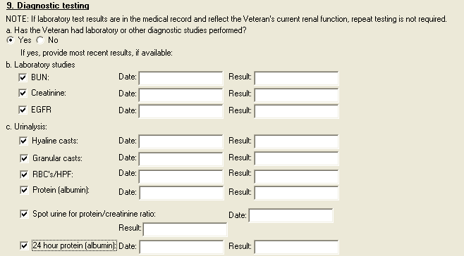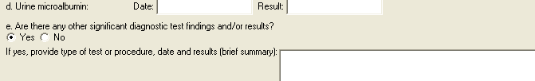

Figure 22: Print Example: DBQ – Kidney Conditions (Nephrology) – 9. Diagnostic testing
9. Diagnostic testing
---------------------
NOTE: If laboratory test results are in the medical record and reflect the
Veteran's current renal function, repeat testing is not required.
a. Has the Veteran had laboratory or other diagnostic studies performed?
[ ] Yes [ ] No
If yes, provide most recent results, if available:
b. Laboratory studies
[ ] BUN: Date: Result:
[ ] Creatinine: Date: Result:
[ ] EGFR: Date: Result:
c. Urinalysis:
[ ] Hyaline casts: Date: Result:
[ ] Granular casts: Date: Result:
[ ] RBC's/HPF: Date: Result:
[ ] Protein (albumin): Date: Result:
[ ] Spot urine for protein/creatinine ratio:
Date: Result:
[ ] 24 hour protein (albumin):
Date: Result:
d. Urine microalbumin: Date: Result:
e. Are there any other significant diagnostic test findings and/or results?
[ ] Yes [ ] No
If yes, provide type of test or procedure, date and results (brief
summary):

Section 10. Functional impact
All questions in this section may be answered as described by the rules below.

Table 11: Rules: DBQ – Kidney Conditions (Nephrology) – 10. Functional impact
Field/Question | Field Disposition | Valid Values | Format | Error Message
10. Functional impact | Enabled; Read-Only | N/A | N/A | N/A
Does the Veteran’s kidney condition(s), including neoplasms, if any, impact his or her ability to work? | If Diagnosis = Yes and at least one diagnosis is selected in the Diagnosis section; Enabled, Mandatory, Choose one valid value  Else; Enabled, Optional | [Yes; No] | N/A | Please answer the question: Does the Veteran’s kidney condition(s), including neoplasms, if any, impact his or her ability to work.
If yes, describe impact of each of the Veteran’s kidney conditions, providing one or more examples: | If Does the Veteran’s kidney condition(s) impact his or her ability to work? = Yes; Enabled; Mandatory | N/A | Free Text | Please describe the impact of each of the Veteran’s kidney condition(s) (including neoplasms, if any) on his or her ability to work, providing one or more examples.

Figure 23: Template Example: DBQ – Kidney Conditions (Nephrology) – 10. Functional impact
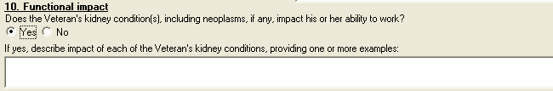

Figure 24: Print Example: DBQ – Kidney Conditions (Nephrology) – 10. Functional impact
10. Functional impact
---------------------
Does the Veteran's kidney condition(s), including neoplasms, if any, impact
his or her ability to work?
[X] Yes [ ] No
If yes, describe impact of each of the Veteran's kidney conditions,
providing one or more examples:

Section 11. Remarks, if any
All questions in this section may be answered as described by the rules below.

Table 12: Rules: DBQ – Kidney Conditions (Nephrology) – 11. Remarks, if any
Field/Question | Field Disposition | Valid Values | Format | Error Message
11. Remarks, if any | Enabled, Optional | N/A | Free Text | N/A

Figure 25: Template Example: DBQ – Kidney Conditions (Nephrology) – 11. Remarks, if any


Figure 26: Print Example: DBQ – Kidney Conditions (Nephrology) – 11. Remarks, if any
11. Remarks, if any
-------------------

Kidney Conditions (Nephrology) DBQ-AMIE Worksheet

The DBQ-AMIE worksheets are accessed via the Print Blank C&P Worksheet menu [DVBA C PRINT BLANK C&P WORKSHE] option. Select the “DBQ KIDNEY CONDITIONS (NEPHROLOGY)” worksheet. DBQ-AMIE worksheets should be sent to a printer.

Kidney Conditions (Nephrology)
Disability Benefits Questionnaire

Name of patient/Veteran: _______________________ SSN: ________________

Your patient is applying to the U. S. Department of Veterans Affairs (VA) for
disability benefits. VA will consider the information you provide on this
questionnaire as part of their evaluation in processing the Veteran's claim.

1. Diagnosis:

Does the Veteran now have or has he/she ever been diagnosed with a kidney
condition?
___ Yes ___ No

If no, provide rationale (e.g., Veteran has never had any known kidney
condition(s)):_______________________________________________________________

If yes, indicate diagnoses: (check all that apply)
___ Diabetic nephropathy ICD Code: ______ Date of Diagnosis: _________
___ Glomerulonephritis ICD Code: ______ Date of Diagnosis: _________
___ Hydronephrosis ICD Code: ______ Date of Diagnosis: _________
___ Interstitial nephritis ICD Code: ______ Date of Diagnosis: _________
___ Kidney transplant ICD Code: ______ Date of Diagnosis: _________
___ Nephrosclerosis ICD Code: ______ Date of Diagnosis: _________
___ Nephrolithiasis ICD Code: ______ Date of Diagnosis: _________
___ Renal artery stenosis ICD Code: ______ Date of Diagnosis: _________
___ Ureterolithiasis ICD Code: ______ Date of Diagnosis: _________
___ Neoplasm of the kidney
ICD Code: ______ Date of Diagnosis: _________
___ Other kidney condition (specify diagnosis, providing only diagnoses
that pertain to kidney conditions.)

Other diagnosis #1: ______________
ICD code: ________________________
Date of diagnosis: _______________

Other diagnosis #2: ______________
ICD code: ________________________
Date of diagnosis: _______________

If there are additional diagnoses that pertain to kidney conditions, list
using above format: _________________________________________________________

2. Medical history

Describe the history (including cause, onset and course) of the Veteran's
kidney condition: ___________________________________________________________

Page: 2

Disability Benefits Questionnaire for
Kidney Conditions (Nephrology)

3. Renal dysfunction

a. Does the Veteran have renal dysfunction?
___ Yes ___ No

If yes, does the Veteran require regular dialysis?
___ Yes ___ No

b. Does the Veteran have any signs or symptoms due to renal dysfunction?
___ Yes ___ No

If yes,check all that apply:

___ Proteinuria (albuminuria)
If checked, indicate frequency: (check all that apply)
___ Recurring ___ Constant ___ Persistent
___ Edema (due to renal dysfunction)
If checked, indicate frequency: (check all that apply)
___ Some ___ Transient ___ Slight ___ Persistent
___ Anorexia (due to renal dysfunction)
___ Weight loss (due to renal dysfunction)
If checked, provide baseline weight (average weight for 2-year period
preceding onset of disease): ____________
Provide current weight: _________________
___ Generalized poor health due to renal dysfunction
___ Lethargy due to renal dysfunction
___ Weakness due to renal dysfunction
___ Limitation of exertion due to renal dysfunction
___ Able to perform only sedentary activity, due to persistent edema
caused by renal dysfunction
___ Markedly decreased function other organ systems, especially the
cardiovascular system, caused by renal dysfunction
If checked, describe: _____________________________________________

c. Does the Veteran have hypertension and/or heart disease due to renal
dysfunction or caused by any kidney condition?
___ Yes ___ No

If yes, also complete the Hypertension and/or Heart Disease Questionnaire
as appropriate.

Page: 3

Disability Benefits Questionnaire for
Kidney Conditions (Nephrology)

4. Urolithiasis

a. Does the Veteran have kidney, ureteral or bladder calculi?
___ Yes ___ No

If yes, indicate location (check all that apply)
___ Kidney ___ Ureter ___Bladder

If the Veteran has urolithiasis, complete the following:

b. Has the Veteran had treatment for recurrent stone formation in the kidney,
ureter or bladder?
___ Yes ___ No

If yes, indicate treatment: (check all that apply)
___ Diet therapy
If checked, specify diet and dates of use: ____________________________
___ Drug therapy
If checked, list medication and dates of use: _________________________
___ Invasive or non-invasive procedures
If checked, indicate average number of times per year invasive or
non-invasive procedures were required:
___ 0 to 1 per year ___ 2 per year ___ > 2 per year
Date and facility of most recent invasive or non-invasive procedure:
_______________________________________________________________________

c. Does the Veteran have signs or symptoms due to urolithiasis?
___ Yes ___ No

If yes, indicate severity (check all that apply):
___ No symptoms or attacks of colic
___ Occasional attacks of colic
___ Frequent attacks of colic
___ Causing voiding dysfunction
___ Requires catheter drainage
___ Causing infection (pyonephrosis)
___ Causing hydronephrosis
___ Causing impaired kidney function
___ Other, describe: ______________________________________________________

Page: 4

Disability Benefits Questionnaire for
Kidney Conditions (Nephrology)

5. Urinary tract/kidney infection

Does the Veteran have a history of recurrent symptomatic urinary tract or
kidney infections?
___ Yes ___ No

If yes, provide etiology: ___________________________________________________

If the Veteran has had recurrent symptomatic urinary tract or kidney
infections, indicate all treatment modalities that apply:
___ No treatment
___ Long-term drug therapy
If checked, list medications used and indicate dates for courses of
treatment over the past 12 months: ____________________________________
___ Hospitalization
If checked, indicate frequency of hospitalization:
___ 1 or 2 per year
___ > 2 per year
___ Drainage
If checked, indicate dates when drainage performed over past 12
months: _______________________________
___ Continuous intensive management
If checked, indicate types of treatment and medications used over
past 12 months: _______________________
___ Intermittent intensive management
If checked, indicate types of treatment and medications used over
past 12 months: _______________________
___ Other, describe: ________________________

6. Kidney transplant or removal

a. Has the Veteran had a kidney removed?
___ Yes ___ No

If yes, provide reason:
___ Kidney donation
___ Due to disease
___ Due to trauma or injury
___ Other, describe: ______________________

b. Has the Veteran had a kidney transplant?
___ Yes ___ No

If yes, date of admission: ___________________
Date of discharge: ___________________________

Page: 5

Disability Benefits Questionnaire for
Kidney Conditions (Nephrology)

7. Tumors and neoplasms

a. Does the Veteran have a benign or malignant neoplasm or metastases
related to any of the diagnoses in the Diagnosis section?
___ Yes ___ No

If yes, complete the following:

b. Is the neoplasm
___ Benign ___ Malignant

c. Has the Veteran completed treatment or is the Veteran currently undergoing
treatment for a benign or malignant neoplasm or metastases?
___ Yes ___ No; watchful waiting

If yes, indicate type of treatment the Veteran is currently undergoing or
has completed (check all that apply):
___ Treatment completed; currently in watchful waiting status
___ Surgery
If checked, describe: ________________________________________________
Date(s) of surgery: _________
___ Radiation therapy
Date of most recent treatment: ___________
Date of completion of treatment or anticipated date of
completion: _________________
___ Antineoplastic chemotherapy
Date of most recent treatment: ___________
Date of completion of treatment or anticipated date of
completion: _________________
___ Other therapeutic procedure
If checked, describe procedure: ______________________________________
Date of most recent procedure: ___________
___ Other therapeutic treatment
If checked, describe treatment: ______________________________________
Date of completion of treatment or anticipated date of
completion: _________________

d. Does the Veteran currently have any residual conditions or complications
due to the neoplasm (including metastases) or its treatment, other than those
already documented in the report above?
___ Yes ___ No

If yes, list residual conditions and complications (brief summary): _________
_____________________________________________________________________________

e. If there are additional benign or malignant neoplasms or metastases
related to any of the diagnoses in the Diagnosis section, describe using the
above format: _______________________________________________________________

Page: 6

Disability Benefits Questionnaire for
Kidney Conditions (Nephrology)

8. Other pertinent physical findings, complications, conditions, signs and/or
symptoms

a. Does the Veteran have any scars (surgical or otherwise) related to any
conditions or to the treatment of any conditions listed in the Diagnosis
section above?
___ Yes ___ No
If yes, are any of the scars painful and/or unstable, or is the total area
of all related scars greater than 39 square cm (6 square inches)?
___ Yes ___ No
If yes, also complete a Scars Questionnaire.

b. Does the Veteran have any other pertinent physical findings,
complications, conditions, signs and/or symptoms?
___ Yes ___ No

If yes, describe (brief summary): ___________________________________________

9. Diagnostic testing

NOTE: If laboratory test results are in the medical record and reflect the
Veteran's current renal function, repeat testing is not required.

a. Has the Veteran had laboratory or other diagnostic studies performed?
___ Yes ___ No

If yes, provide most recent results, if available:

b. Laboratory studies
___ BUN: Date: ___________ Result: ______________
___ Creatinine: Date: ___________ Result: ______________
___ EGFR: Date: ___________ Result: ______________

c. Urinalysis:
___ Hyaline casts: Date: ___________ Result: ______________
___ Granular casts: Date: ___________ Result: ______________
___ RBC's/HPF: Date: ___________ Result: ______________
___ Protein (albumin): Date: ___________ Result: ______________
___ Spot urine for
protein/creatinine ratio: Date: ___________ Result: ______________
___ 24 hour protein (albumin): Date: ___________ Result: ______________

d. Urine microalbumin: Date: ___________ Result: ______________

e. Are there any other significant diagnostic test findings and/or results?
___ Yes ___ No

If yes, provide type of test or procedure, date and results (brief summary):
_____________________________________________________________________________

Page: 7

Disability Benefits Questionnaire for
Kidney Conditions (Nephrology)

10. Functional impact

Does the Veteran's kidney condition(s), including neoplasms, if any, impact
his or her ability to work?
___ Yes ___ No

If yes, describe impact of each of the Veteran's kidney conditions, providing
one or more examples: _______________________________________________________

11. Remarks, if any: ________________________________________________________

Physician signature: _____________________________________ Date: ____________

Physician printed name: __________________________________ Phone: ___________

Medical license #: _______________________________________ Fax: _____________

Physician address: __________________________________________________________

NOTE: VA may request additional medical information, including additional
examinations if necessary to complete VA's review of the Veteran's
application.

